

**VITC 360**

360°Virtua­­­­­­­­l Tour Of Chennai

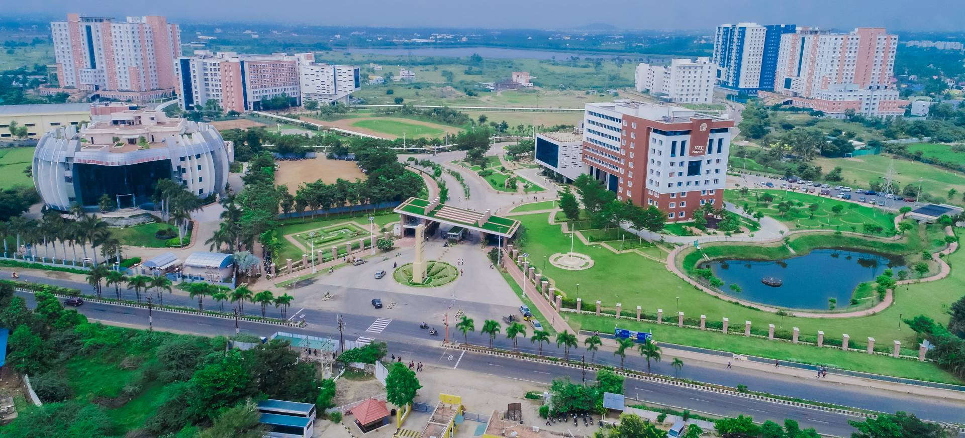­

**Team Members**

Aakash R 20BCE1003

Subramanian Nachiappan 20BCE1019

Prithvi MR 20BAI1146

Nischit KR 20BAI1159

**Under Guidance Of**

Dr.Geetha.S

**School name:** School of Computing Science and Engineering

**Faculty name (ERP No):** Dr.Geetha.S, (50587)

**Academic Year:** 2022-2023 (Winter Semester 22-23) **Title of the project:** 360°Virtual Tour of VIT Chennai

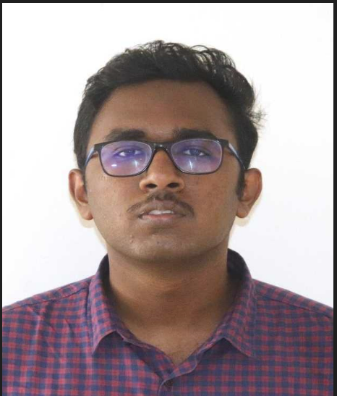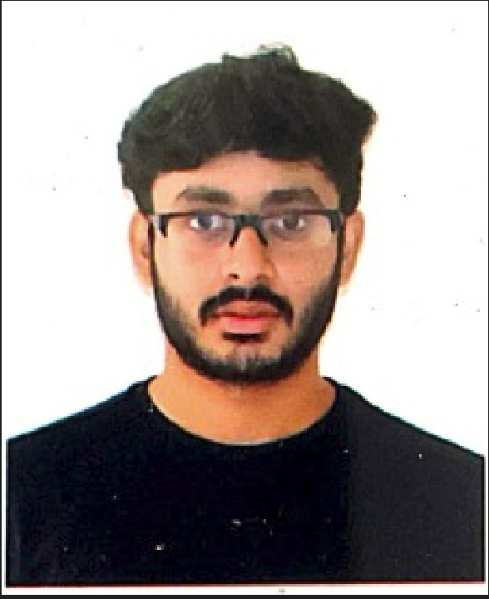

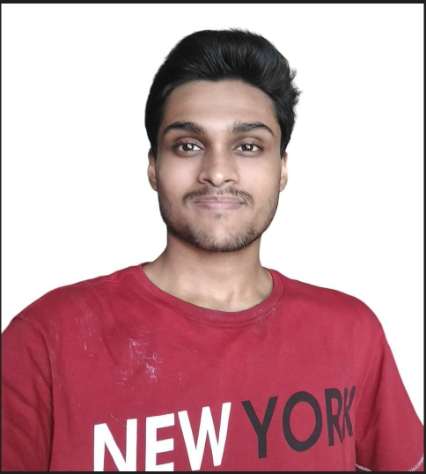 Aakash R 20BCE1003 Subramanian Nachiappan 20BCE1019



Nischit KR 20BAI1159 Prithvi MR 20BAI1146

|  |  |
| --- | --- |
| Table of Content |  |
| **Chapter 1: Introduction** | **1** |
| 1.1 Abstract | 1 |
| 1.2 Problem Definition | 1 |
| 1.3 Motivation | 2 |
| 1.4 Existing System Limitations | 3 |
| 1.5 Solution Uniqueness | 5 |
| **Chapter 2: Scope of Project** | **7** |
| 2.1 Problem Specificity | 7 |
| 2.2 Relevance to Recent Times | 8 |
| 2.3 Statistics | 9 |
| **Chapter 3: Architecture**  **Chapter 4: Project Component** | **13**  **13** |
| 3.1 Hardware Requirements | 14 |
| 3.2 Software Requirements  3.3 Cost of Equipment | 16  17 |
| **Chapter 5: Methodology** | **18** |
| 4.1 Insta 360 Studio File Format Conversions | 18 |
| 4.2 Sequential Arrangement and Labelling | 18 |
| 4.3 Arrow Based Navigation | 19 |
| 4.4 Menu Based Navigation | 20 |
|  |  |
| **Chapter 6: Implementation** | **22** |
| **Chapter 7: Sample Photos** | **23** |
| **Chapter 8: Benefits** | **26** |

**Chapter 1-Introduction**

* 1. **ABSTRACT**

VIT University's campus is vast and consists of numerous buildings and landmarks, making it challenging for new visitors to navigate. The project aims to address this problem by providing a comprehensive navigation solution. The project includes capturing high-quality 360-degree photographs of various buildings, including both the exterior and interior views. The buildings covered include Aavin Milk Parlour, Health Centre, ATM, Delta Block, AB2, B-Block, C-Block, Gazebo, Lassi House, MGR Statue, Clock Court, Admin block, Central Library, VOC Auditorium, MG Auditorium, AB1, Nethaji Auditorium, A-Block, Gym, GymKhanna, Dominos, and V-Mart. The 360-degree photographs are integrated into an interactive navigation interface, allowing users to select a building or landmark from a list and view the corresponding photograph and audio description. The navigation interface is hosted on a reliable and scalable platform, making it easily accessible to all members of the campus community.The project provides a valuable resource for students, staff, and visitors to navigate the campus effectively. The project components were carefully designed to ensure the accuracy and completeness of the 360-degree photographs and to ensure the usability, functionality, and performance of the navigation interface. This project serves as a convenient and accessible solution for navigating VIT University's campus, saving time and reducing confusion for visitors.

Website link:- <https://webobook.com/public/641a9edea5908052e1232e82,en>

* 1. **PROBELM DEFINITION**

This project seeks to address the challenge faced by the students, staff, and visitors of VIT University in navigating the vast campus efficiently. The complexity of the campus's layout, as well as the multitude of buildings and landmarks, can pose difficulties for individuals, particularly new visitors. The consequent confusion, delays, and time wastage are a significant impediment to the smooth functioning of the institution. Therefore, the project's goal is to provide an optimal solution by creating a comprehensive 360-degree walkthrough of the campus's various buildings and landmarks. This walkthrough includes both exterior and interior views, facilitating easy orientation for individuals. Overall the problem statement addressed in this project is the lack of a comprehensive and engaging virtual tour of the VIT Chennai campus using 360-degree technology. While there may be some virtual tours available online, they may lack interactivity and may not provide a seamless experience to the user. Prospective students and visitors may find it challenging to get a sense of the campus's enormous layout and facilities, which can impact their decision to join or visit the institute.

* 1. **MOTIVATION**

The Vellore Institute of Technology (VIT) Chennai campus is one of the leading educational institutions in India, offering a wide range of undergraduate and postgraduate programs in various disciplines. The institute attracts students from across the country and around the world, with its world-class facilities, experienced faculty, and innovative teaching methods. While the institute offers a range of opportunities for students, faculty, and researchers, it can be challenging for prospective students and visitors to get a sense of the campus's layout and facilities. The COVID-19 pandemic has further exacerbated this issue, with restrictions on physical visits and campus tours. To address this challenge, we propose to create a virtual tour of the VIT Chennai campus using 360-degree technology. This virtual tour will enable visitors to explore the campus virtually and get a feel for the institute's facilities without actually being there physically. In this section, we discuss the problem statement, existing solutions, our proposed solution, the unique contributions of our project, the technical details of our project, and the expected impact of our project

The impetus for this project lies in the aspiration to improve the navigation experience of VIT University's campus for its students, staff, and visitors. Given the campus's size and the plethora of buildings and landmarks it houses, locating a destination can be a daunting task, especially for newcomers. Thus, the project aims to offer a remedy by creating a 360-degree walkthrough of the campus's various buildings and landmarks. The provision of concise audio descriptions of each structure further aids in wayfinding, thereby ensuring that individuals can seamlessly navigate through the campus. This project can be particularly advantageous for those with disabilities or mobility issues as it allows them to explore the campus virtually, making informed decisions about their visit. In summary, this project seeks to provide a convenient and accessible navigation solution, thereby enhancing the overall campus experience for all.

Despite being a prominent institute for engineering and technology education in India, VIT Chennai faces the challenge of limited physical access to its campus due to the ongoing COVID-19 pandemic and the limitations it has imposed on campus visits. This has put a restriction on the number of prospective students visiting the campus and exploring its facilities. To address this challenge, VIT Chennai needs a solution that can provide a virtual experience of the campus to prospective students and parents, showcasing its facilities and creating an engaging and immersive experience that can rival a physical visit. A 360-degree virtual tour can be a promising solution to address this problem and provide an alternative experience that can attract and engage potential students, despite the limitations on physical access.

* 1. **Existing System and Limitations**

The existing system for virtual tours in educational institutions involves the use of specialized software or platforms that allow users to create and share immersive, 360-degree virtual tours of their campus facilities. These platforms are designed to provide a realistic, interactive experience that simulates a physical visit to the campus. There are various platforms that allow users to create custom tours that can include 360-degree panoramic views, multimedia content such as videos, photos, and descriptions, and interactive elements such as clickable hotspots that provide additional information or context.

One example of an existing virtual tour for an educational institution in India is the virtual tour of Indian Institute of Technology (IIT) Bombay. The tour provides an interactive, 360-degree view of the campus and its facilities, allowing users to explore different areas of the campus through panoramic views. The tour includes locations such as the academic buildings, lecture halls, hostels, sports facilities, and student activity areas. The virtual tour also includes multimedia content such as videos and descriptions of each location, providing users with a comprehensive understanding of the campus and its offerings. The virtual tour of IIT Bombay is available on the institution's website and provides an engaging and informative experience to prospective students, parents, and other stakeholders who are interested in learning more about the institution.

Another example of an existing virtual tour is the virtual tour of Harvard University. The tour allows users to explore Harvard's historic campus through a series of 360-degree panoramic views, accompanied by multimedia content such as photos, videos, and descriptions of each location. Users can navigate through the tour using a map interface, and can click on hotspots to learn more about specific locations and facilities. The tour covers a range of campus facilities, including academic buildings, libraries, student housing, and athletic facilities. Overall, the tour provides a highly immersive and engaging experience that simulates a physical visit to the Harvard campus.

There are several limitations to the existing system for virtual tours in educational institutions:

1. Technical limitations: Creating high-quality virtual tours requires specialized equipment such as 360-degree cameras, drones, and editing software, which can be expensive and require technical expertise. As a result, smaller institutions or those with limited budgets may not be able to create virtual tours that are as comprehensive or engaging as larger institutions.
2. Limited interactivity: While virtual tours provide an immersive and interactive experience, they can still feel somewhat static and limited in terms of interactivity. Users may not be able to customize the tour or interact with the environment in the same way they would during a physical visit.
3. Lack of personalization: Virtual tours are designed to provide a broad overview of the campus facilities, but they may not be able to provide the same level of personalization or individual attention that prospective students may receive during a physical campus visit. This can be a drawback for students who are looking for a more personalized experience.
4. Accessibility: Virtual tours rely on digital platforms and equipment, which may not be accessible to all users, particularly those with disabilities or limited access to technology. This can create barriers for some users who may not be able to fully engage with the virtual tour.
5. Inaccuracies: While virtual tours aim to provide an accurate representation of the campus facilities, they may not always be up-to-date or fully representative of the actual campus environment. This can be a drawback for prospective students who are trying to get a sense of the campus culture and atmosphere.

Overall, while virtual tours offer many benefits for educational institutions, there are still some limitations that need to be addressed to ensure that they provide a comprehensive and engaging experience for all users.

* 1. **Solution Uniqueness**

The 360 virtual tour of VIT Chennai offers several unique solutions and effective tool for showcasing the campus facilities and offerings that make it a unique to address the limitations of existing virtual tour systems:

1. Personalization: The 360 virtual tour of VIT Chennai offers users the ability to customize their experience by choosing their own path and exploring the campus facilities at their own pace. This feature allows users to focus on the areas of the campus that are most relevant to them, and to spend more time on those areas that they find most interesting or important. Users can also revisit areas of the campus as many times as they like, providing a more in-depth and personalized experience.
2. Enhanced interactivity: The 360 virtual tour of VIT Chennai includes several interactive features that make the tour more engaging and informative. For example, users can click on hotspots to learn more about specific areas of the campus, such as classrooms, laboratories, and student centers. They can also view multimedia content such as photos and videos that provide a more detailed look at different parts of the campus. This interactivity makes the tour more immersive and helps users to better understand the campus environment.
3. Accessibility: The 360 virtual tour of VIT Chennai is designed to be accessible to all users, regardless of their abilities or access to technology. The tour includes features such as audio descriptions and closed captions, which can make the tour more accessible to users with visual or hearing impairments. The tour is also designed to be compatible with a wide range of devices and platforms, making it accessible to users who may not have access to the latest technology.
4. Real-time updates: The 360 virtual tour of VIT Chennai is regularly updated to reflect changes to the campus facilities and environment. This ensures that the tour provides an accurate and up-to-date representation of the campus, which is important for prospective students who are considering attending the institution. Real-time updates also ensure that the tour remains relevant and useful over time, and can help to attract a wider audience of users.
5. Cost-effective: The 360 virtual tour of VIT Chennai is a cost-effective solution for educational institutions that may not have the resources to create their own virtual tours. By providing a comprehensive and engaging virtual tour, institutions can reach a wider audience and showcase their facilities and offerings in an effective way. This can help to increase interest and enrollment in the institution, and can also provide a more accessible and convenient way for users to learn about the campus.

In summary, the 360 virtual tour of VIT Chennai offers several innovative solutions that make it a unique and effective tool for showcasing the campus facilities and offerings. By providing a personalized, interactive, accessible, and cost-effective virtual tour, VIT Chennai can reach a wider audience of prospective students and provide a more engaging and informative way for users to learn about the campus.

**Chapter 2-Scope Of Project**

* 1. **Problem Specificity**

The problem specificity for the above-described problem of VIT Chennai is complex and multifaceted, with several distinct aspects that need to be addressed in order to attract and engage potential students and stakeholders.

The various aspects has been discussed below:-

The first aspect of the problem is the ongoing COVID-19 pandemic, which has created limitations on physical access to the campus. The pandemic has made it difficult for prospective students and stakeholders to visit the institution in person and explore its facilities. This lack of physical access can make it challenging for students to evaluate the institution and make informed decisions about their educational future. In order to address this aspect of the problem, VIT Chennai will need to find alternative ways to provide potential students and stakeholders with a sense of the campus environment, facilities, and overall culture.

The second aspect of the problem is the lack of campus visits, which can also impact the institution's marketing and outreach efforts. Campus visits and events are essential tools for institutions to attract and engage potential students and stakeholders. The absence of these events can make it difficult for institutions to stand out in a crowded market and attract the attention of potential students. In order to address this aspect of the problem, VIT Chennai will need to find alternative ways to showcase the institution's unique selling points and value proposition to potential students and stakeholders.

The third aspect of the problem involves addressing the changing needs and preferences of stakeholders in a rapidly evolving digital landscape. With the rise of online learning and remote work, students and their families are increasingly relying on digital means to explore and evaluate potential universities and colleges. Educational institutions that can offer a compelling virtual experience to their stakeholders are more likely to stand out in a crowded market and attract the attention of potential students and stakeholders. In order to address this aspect of the problem, VIT Chennai will need to adapt to the changing needs and preferences of stakeholders in a digital landscape and provide a seamless and engaging virtual experience that can replicate a physical visit.

In summary, the problem specificity for the above-described problem of VIT Chennai involves addressing the challenges and efforts involved in physical campus visits by providing a virtual experience that can replicate a physical visit, showcasing the campus environment, facilities, and culture, and adapting to the changing needs and preferences of stakeholders in a digital landscape. By addressing these distinct aspects of the problem, VIT Chennai can attract and engage potential students and stakeholders, stand out in a crowded market, and continue to provide a high-quality educational experience for its students.

* 1. **Relevance to Recent Times**

The COVID-19 pandemic has caused unprecedented disruption in the education sector, leading to the closure of schools and universities worldwide. This has forced educational institutions to adopt new ways of teaching and interacting with their stakeholders, including students, parents, and faculty members. In this context, digital technologies have played a critical role in enabling institutions to continue their operations and maintain their engagement with their stakeholders. Virtual tools and platforms, including 360-degree virtual tours, have emerged as a valuable solution for educational institutions to provide an immersive and engaging experience to their stakeholders, despite the limitations on physical access. 360 virtual tours are invaluable to many types of business. However, it’s their unique ability to showcase the entire three dimensional space that makes them particularly valuable to the architecture, interior design, property and real estate industries.

In recent times, the adoption of virtual tours has increased significantly in various industries, including education, tourism, and real estate. This trend is driven by the need to provide an alternative experience to stakeholders who are unable or unwilling to visit physical locations. Virtual tours provide a cost-effective and scalable solution to showcase products, services, and locations, providing an immersive and engaging experience that can replicate a physical visit.

For educational institutions like VIT Chennai, virtual tours can be a valuable tool to showcase their campus and facilities to potential students and other partners and collaborators. A 360-degree virtual tour can provide an interactive and immersive experience that can help prospective students visualize the campus, explore its facilities, and get a sense of the overall environment. This can be particularly useful for international students who are unable to visit the campus due to travel restrictions or logistical challenges.Furthermore, virtual tours can also provide a convenient and accessible way for institutions to conduct virtual events, such as campus tours, open houses, and information sessions. With virtual tools, institutions can provide a seamless and personalized experience to their stakeholders, allowing them to interact with the faculty, staff, and students and get a sense of the culture and values of the institution.

Overall, the relevance of a 360-degree virtual tour for VIT Chennai in recent times is driven by the need to adapt to the changing needs and preferences of its stakeholders and to provide an engaging and immersive experience that can rival a physical visit. With the pandemic's impact likely to persist in the foreseeable future, the adoption of virtual tools and platforms is likely to become increasingly important for educational institutions to maintain their engagement with their stakeholders and remain competitive in a crowded market.

* 1. **Statistics**

The statistics about virtual tours in educational institutions suggest that they are an increasingly popular and effective tool for engaging with stakeholders and showcasing campus facilities. The COVID-19 pandemic has accelerated the adoption of virtual technologies in education, including virtual tours, as institutions seek to provide an immersive and engaging experience to prospective students and other stakeholders who may be unable to visit campuses in person.

According to the World Economic Forum, the virtual tour market in education is expected to grow at a compound annual growth rate (CAGR) of over 16% between 2021 and 2026. This growth is driven by the increasing demand for virtual tools that can provide an immersive and engaging experience to stakeholders in the education sector. The report also suggests that virtual tours have the potential to become a significant revenue stream for educational institutions, providing a new source of income for institutions that are struggling with declining enrolment and revenue due to the pandemic.

A study by Campus Tours Inc. found that institutions that provide virtual tours to their prospective students experience a 64% increase in applications and a 31% increase in campus visits. The study also found that virtual tours are particularly effective in attracting international students, as they provide a cost-effective and convenient alternative to physical visits.

Moreover, the study highlights that virtual tours are a valuable tool for institutions to showcase their campus and facilities, allowing them to provide an immersive

and engaging experience to stakeholders that can rival a physical visit. Virtual tours can help institutions differentiate themselves from their competitors, enhance their brand awareness, and increase their overall visibility in the market. This is particularly important in today's increasingly competitive educational landscape, where institutions must find new and innovative ways to attract and retain students.

A report by the Association of American Colleges and Universities (AAC&U) found that virtual tours can be an effective tool for institutions to engage with their stakeholders, including students, faculty, and staff. The report states that virtual tours can provide a personalized and interactive experience to stakeholders, allowing them to explore the campus and its facilities, learn about the institution's values and culture, and engage with faculty and staff. This level of engagement can help to build stronger relationships with stakeholders and promote a sense of community within the institution.

The statistics about virtual tours in educational institutions suggest that they are an increasingly relevant and valuable solution for institutions seeking to engage with their stakeholders and showcase their campus facilities. The growth of the virtual tour market in education is expected to continue in the coming years, making virtual tours an important tool for educational institutions looking to differentiate themselves, increase their brand awareness, and attract and retain students in an increasingly competitive landscape.

Nearly all types of business can benefit from 360 virtual tour technology. Whilst photos and videos are effective, they’re becoming standard and losing their impact. When a business has an interactive 360 virtual tour created, it offers something unique, immersive and cutting edge. For this reason alone, interactive 360 media has a far higher impact and is considered far more ‘sticky’ than more traditional forms of image content.

Here are some statistics from an independent survey commissioned by Google:

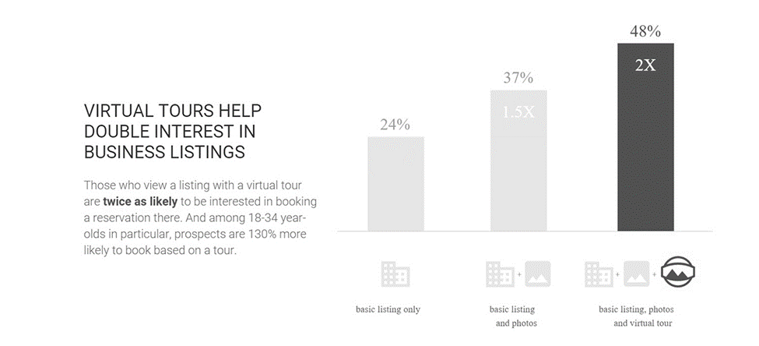

Fig.1. The power of media rich listings with 360 virtual tours.

The longer a visitor spends on a web page, the higher it will rank in search results. When there’s a virtual tour to maintain interest, visitors are much more likely to resist leaving a website. This can boost Google SEO results considerably, and is therefore becoming an increasingly important element of commercial marketing strategies.

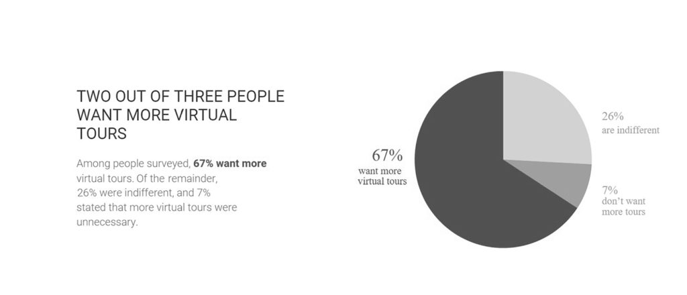

Fig.2. The majority of internet users would like to see more 360 virtual tours.

Adding 360 virtual tours to a website is still a relatively new concept, which means that many businesses don’t have one yet. By adding a 360 virtual tour to a website before the competition, a business will stand out and be ahead of the curve – increasing brand identity and ultimately profit.

More and more companies are adopting 360 media as their benefits are becoming increasingly apparent. This trend is expected to continue as marketers recognise the un paralleled and unique potential of 360 virtual tours.

Since early 2020, the global Coronavirus pandemic has accelerated this growth exponentially, as we are now all leading more virtual lives and unnecessary travel has been restricted.

Also, the National Association of Realtors in the USA, has a vested interest in determining if 360 virtual tours are helping or hurting their member’s businesses. Their annual reports are always great sources of research into the subject. Here are some of their recent findings:

* A listing with a virtual tour gets around 87% more views than those without 360 virtual tours.
* Over 50% of buyers will not even look at a property unless it has a 360 virtual tour.
* The majority of internet users found 360 virtual tours to be a significant factor in influencing their purchasing decision.
* 360 virtual tours reduce the number of wasted viewing hours by 40%, saving the vendor time and money.

**Chapter 3- Architecture**

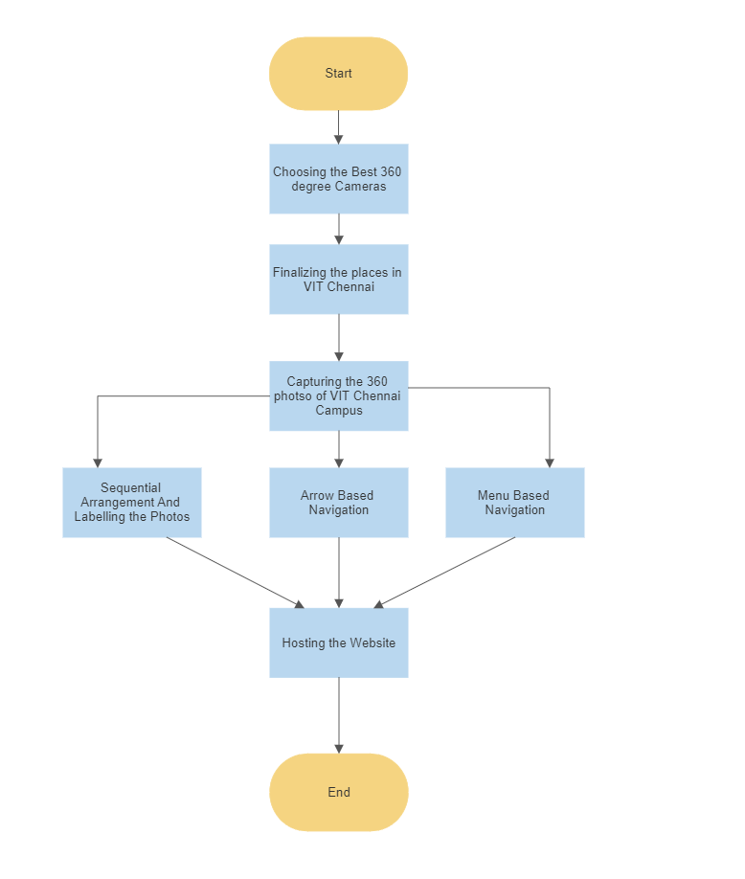

**Chapter 4- Project Components**

Creating a successful 360 virtual tour of VIT Chennai requires careful planning and attention to detail. There are several project components that must be considered to ensure that the tour provides a seamless and engaging user experience. These components include camera equipment, software and editing tools, virtual tour platform, tour interface design, audio and video components, accessibility features, and testing and optimization. Each of these components plays an essential role in creating a high-quality tour that showcases the campus facilities and environment, and provides an immersive and informative experience for users. In this discussion, we'll take a closer look at the importance of each of these project components and how they contribute to the success of the 360 virtual tour of VIT Chennai.

**4.1) Hardware Requirements**

Capturing high-quality 360-degree images for the virtual tour of VIT Chennai requires the right camera equipment. Hardware requirements for the project are critical to ensure that the images captured are of high resolution, and the tour provides an immersive and realistic experience for users. From choosing the right camera lens to selecting the ideal tripod, every hardware component used in the project must be carefully considered. After examining the different types of cameras and lenses that are best suited for capturing 360-degree images, the importance of selecting the right tripod, and other hardware considerations that can impact the quality of the final tour. The suitable 360 degree camera and Tripod was selected for creating a successful 360 virtual tour of VIT Chennai.

1. **Insta360 One R Twin Edition- 360 Degree Camera**

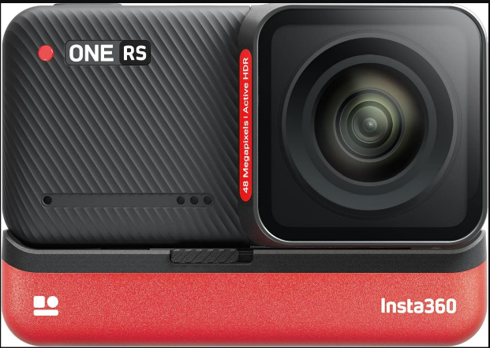

Fig.3. Insta360 Twin R Camera

The Insta360 One R Edition Camera is a versatile camera that can capture 360-degree images as well as traditional 4K video. This camera features a modular design, which allows users to switch out the lens module and choose the lens that is best suited for their needs. The 360-degree lens module captures high-quality images with a resolution of up to 5.7K, providing a detailed and immersive view of the surroundings.

The camera also features FlowState Stabilization, which uses advanced algorithms to keep the footage steady and smooth, even when shooting in challenging environments. This feature is essential for creating a seamless and immersive virtual tour of VIT Chennai. Another important feature of the Insta360 One R Edition Camera is its ability to shoot in low light conditions. The camera's Night Shot feature uses a high-sensitivity sensor and advanced image processing to capture clear and detailed images even in low light environments.T he camera is also compact and portable, making it easy to carry around campus and capture images from different angles and perspectives. Additionally, the camera's waterproof design makes it suitable for capturing images in wet or humid environments, such as indoor swimming pools or rain.

Overall, the Insta360 One R Edition Camera is an ideal choice for capturing high-quality 360-degree images for the virtual tour of VIT Chennai. Its modular design, Flow State Stabilization, low light capabilities, portability, and waterproof design make it a versatile and reliable camera for this project.

1. **Tripod Stand of Insta 360 Camera**

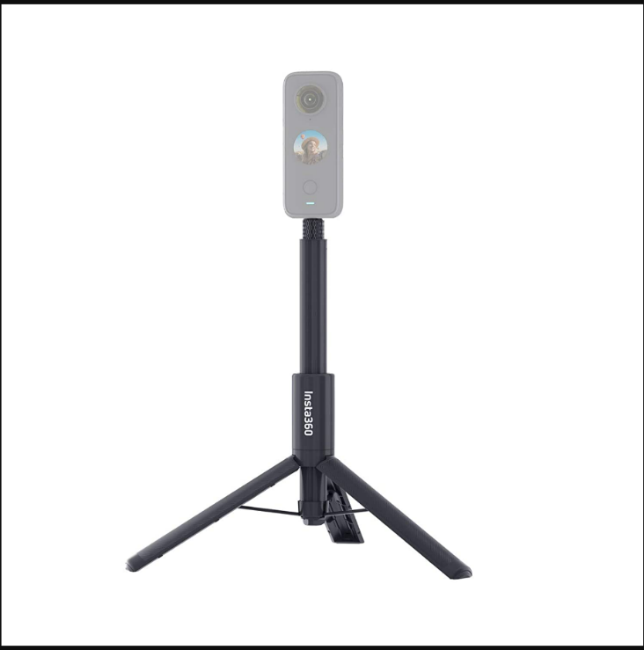

Fig.4.Selfie Stick with inbuilt Tripod

A tripod is an essential component for capturing high-quality 360-degree images for the virtual tour of VIT Chennai. A stable and sturdy tripod can help ensure that the camera remains in place and steady during image capture, reducing blur and distortion and resulting in a more realistic and immersive tour experience.

The tripod is constructed from durable aluminum and features a three-section design, providing stability and support during image capture. It also includes a center column that can be adjusted for height and angle, allowing for additional flexibility in image capture. The tripod also includes a quick-release plate, Its adjustable height, maximum load capacity, stability, and quick-release plate make it an ideal choice for this project. which allows for quick and easy camera mounting and dismounting. Its adjustable height, maximum load capacity, stability, and quick-release plate make it an ideal choice for this project. Therefore it is a reliable and versatile tripod that is well-suited for capturing high-quality 360-degree images for the virtual tour of VIT Chennai.

**4.2) Software Requirements**

1. **Insta360 Studio App**

INSTA360 Studio is a software application that is designed for editing and post-processing of 360-degree images and videos captured using Insta360 cameras. This software offers a range of features and tools that are specifically designed for editing and creating immersive and interactive virtual tours. One of the key features of INSTA360 Studio is its ability to stitch together multiple images or video clips into a single, seamless 360-degree view. The software uses advanced algorithms to accurately align and blend the images, resulting in a smooth and realistic view of the environment. Overall, INSTA360 Studio is a powerful and versatile software application that is essential for creating high-quality virtual tours using Insta360 cameras. Its stitching capabilities, editing tools, special effects, and export options make it an indispensable tool for any virtual tour project.

1. **WeboBook-Virtual Tour**

The platform is designed to be user-friendly and accessible, allowing anyone to create virtual tours without requiring specialized technical skills or knowledge. One of the key features of Webobook is its drag-and-drop interface, which allows users to easily add and arrange 360-degree images and videos to create a seamless virtual tour. The platform also includes a range of customization options, such as the ability to add interactive hotspots, custom branding, and multimedia content, such as audio and video.

Webobook also offers a range of sharing options, allowing users to easily publish their virtual tours on websites, social media, and other online platforms. The virtual tours created using Webobook can be embedded on websites, shared via a URL, or accessed through a QR code, making it easy for anyone to view the tour from any device. In addition to its core features, Webobook also offers advanced analytics and tracking tools, allowing users to monitor engagement and interactions with their virtual tours. This can provide valuable insights into how users are interacting with the tour, allowing for further optimization and customization to enhance the user experience. Overall, Webobook is a powerful and user-friendly platform for creating immersive virtual tours. Its drag-and-drop interface, customization options, and sharing features make it an ideal choice for anyone looking to create and publish high-quality virtual tours.

**4.3) Cost of Equipment**

|  |  |
| --- | --- |
| **Equipment** | **Cost** |
| Insta 360 Camera Rent | ₹ 2500 |
| Webobook 360 Virtual Tour Software | ₹ 1000 |
| **Total Cost** | ₹ **3500** |

**Chapter 5- Methodology**

**5.1) 360 Studio File Format Conversions**

Insta360 Studio is a free software program designed to edit and process 360-degree images and videos captured by Insta360 cameras. It can also convert INSPI files to JPG format. Here's how to convert INSP files to JPG using Insta360 Studio:

* Open Insta360 Studio and import the INSP files you want to convert.
* Select the INSPI files in the Media Library.
* Click on the Export button located at the bottom right of the screen.
* Choose the Export Settings you want to use, such as file format, image size, and quality.
* In the "Format" section, select JPG from the dropdown menu.
* Click on the "Export" button to start the conversion process.

Insta360 Studio will convert the INSP files to JPG and save them in the location you specified in the Export Settings. After saving the images in a folder and it will be ready for uploading the jpg photos to the webobook software.

**5.2) Sequential Arrangement and Labelling**

* Open the Webobook software and create a new album for the Vit Chennai 360 photos.
* Import the photos into the album by selecting the "Import" button and browsing for the photos on your computer.
* Once the photos are imported, you can arrange them in the desired order by dragging and dropping them into position.
* To label the photos, click on each photo and enter the relevant information in the "Caption" field. This could include details about the location, date, and any other relevant information.
* After capturing the photographs, they were edited and stitched together using specialized software to create panoramic views of each location. These panoramas were then integrated into a software program that enabled the creation of the virtual tour.
* In addition to the panoramic views, 23 recorded audio descriptions of each building and landmark. The audio descriptions were recorded by professional voice-over artists and provided brief information about each location, such as its name, purpose, and location.

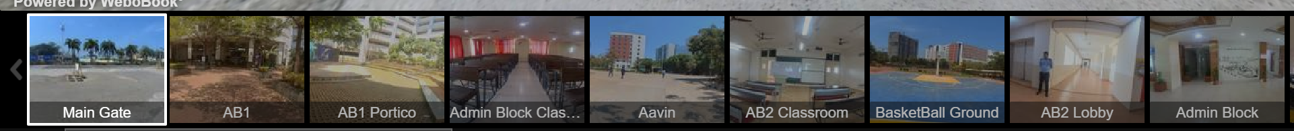

Fig.5. Labelling the places in VIT CHENNAI-I



Fig.6. Labelling the places in VIT CHENNAI-II

**5.3) Arrow Based Navigation**

* Open the Webobook software and create a new project for your virtual tour.
* Import the Vit Chennai 360 photos into the project by selecting the "Import" button and browsing for the photos on your computer.
* Arrange the photos in the desired order by dragging and dropping them into position.
* Click on the first photo in the sequence to select it.
* Click on the "Add Hotspot" button and drag the hotspot to the desired location on the photo.
* In the "Hotspot Properties" dialog box, select the "Label" tab and enter the text you want to appear when the hotspot is clicked.
* You can also customize the appearance of the hotspot by selecting the "Appearance" tab and choosing a different shape, color, or icon.
* Repeat steps 5-7 for each hotspot you want to add to the photo.
* Once you have added all of the hotspots and labels to the first photo, click on the "Next" button to move to the next photo in the sequence.
* Repeat steps 5-9 for each photo in the sequence.
* Once you have added hotspots and labels to all of the photos, you can preview the virtual tour by selecting the "Preview" button.
* If you are satisfied with the virtual tour, you can save it and share it with others.

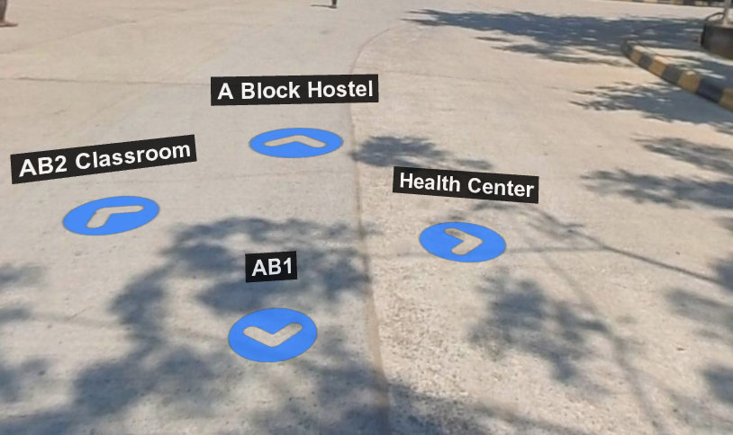

Fig.7.Hotspots for Navigations

**4.4) Menu Based Navigation**

The menu system in the VIT Chennai 360 virtual tour is typically located at the top or left-hand side of the screen, and it includes different categories or sections such as "Academics," "Campus Life," "Sports," and "Facilities." When users click on one of these categories, they are presented with a dropdown menu that includes subcategories or specific pages within that section. For example, under "Facilities," users might see options for "Hostel," "Library," and "Medical Center."Once users select a specific category or page from the menu system, they are taken to that section of the virtual tour. This allows users to easily navigate through the various sections of the tour without having to manually search for specific pages or features.Overall, menu-based navigation in the VIT Chennai 360 virtual tour provides an intuitive and user-friendly way for visitors to explore the campus and learn more about all that it has to offer.

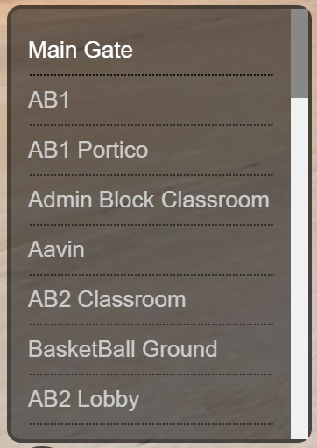

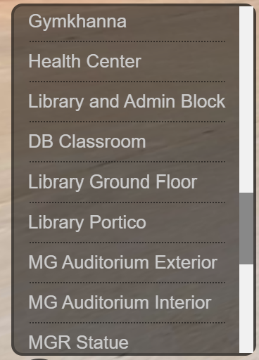

Fig.8.Menu Based Naviagtion

**Chapter 5-Implementation**

The implementation of this project involved several stages, starting with the procurement of the necessary equipment and software. Then we acquired a high-resolution camera with a fisheye lens, a tripod, and specialized software for capturing and editing 360-degree photographs. Next, we conducted a survey of the VIT University campus to identify the buildings and landmarks to include in the virtual tour. After finalizing the list of locations, the we created a detailed plan for capturing photographs of each location. The plan included the placement of the camera at strategic locations to capture panoramic views of the buildings' interior and exterior. The we then captured 360-degree photographs of each location, carefully stitching them together to create panoramic views. The photographs were edited to ensure that they were of high quality and suitable for integration into the virtual tour software. After the photographs the best photographs where selected from the multiple photographs which were taken and using the Insta360 studio the file format from INSP(360 format) to jpg so that it can be uploaded in the webobook software. The hotspot are added and labelled accordingly to the places. So that the user can navigate from one place to another place using it. The menu based navigation is also created for all the places which has been uploaded so it will be convenient for the user navigation. After connecting all the panoramic images. The virtual tour is made public and published using the same webobook using the url link the user from any where around the world can view the virtual tour of the VIT Chennai Campus.

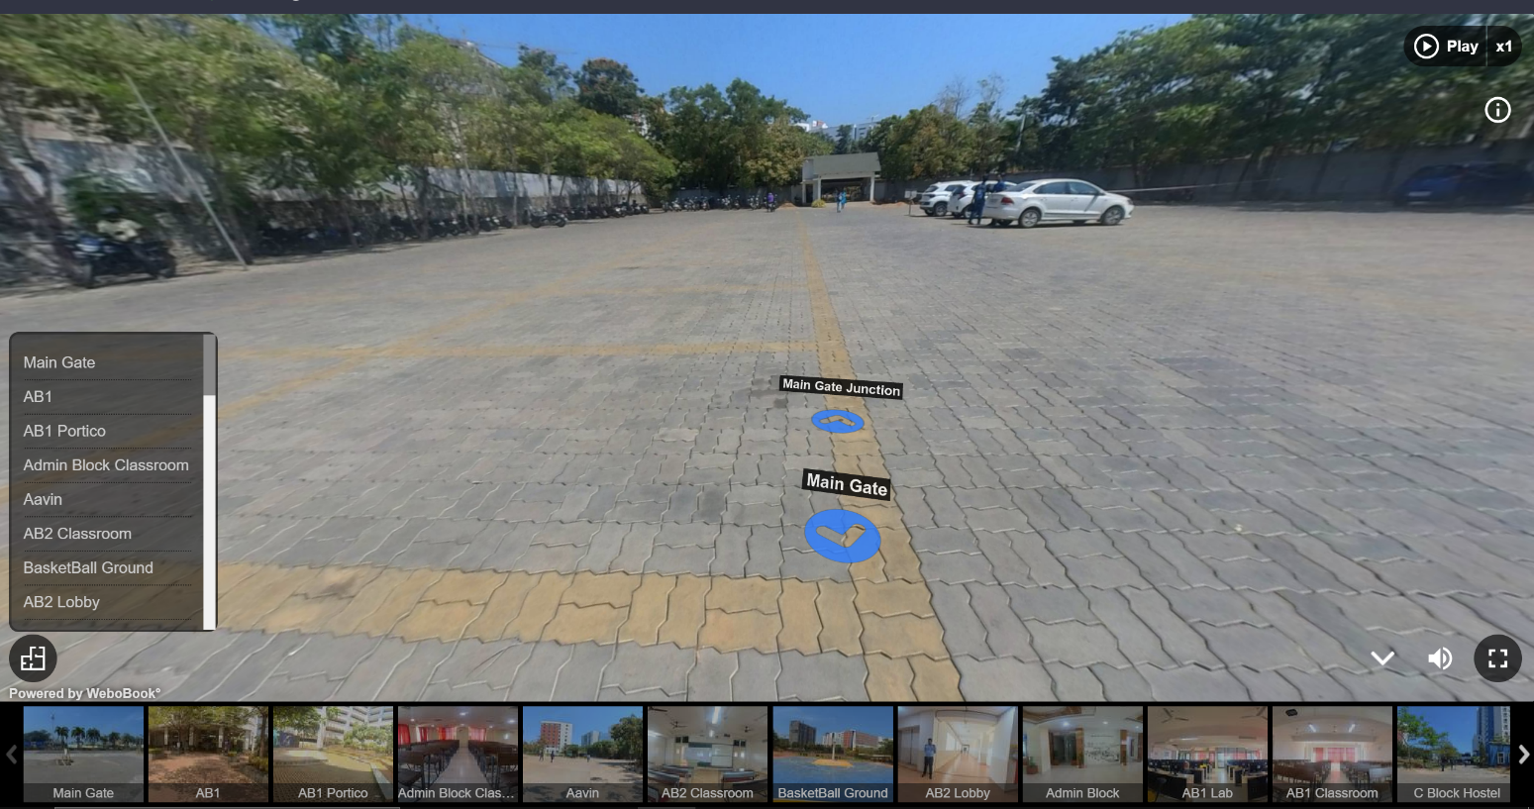**Chapter 6-Sample Photos**

Fig.5.Student Parking Lot- VIT CHENNAI

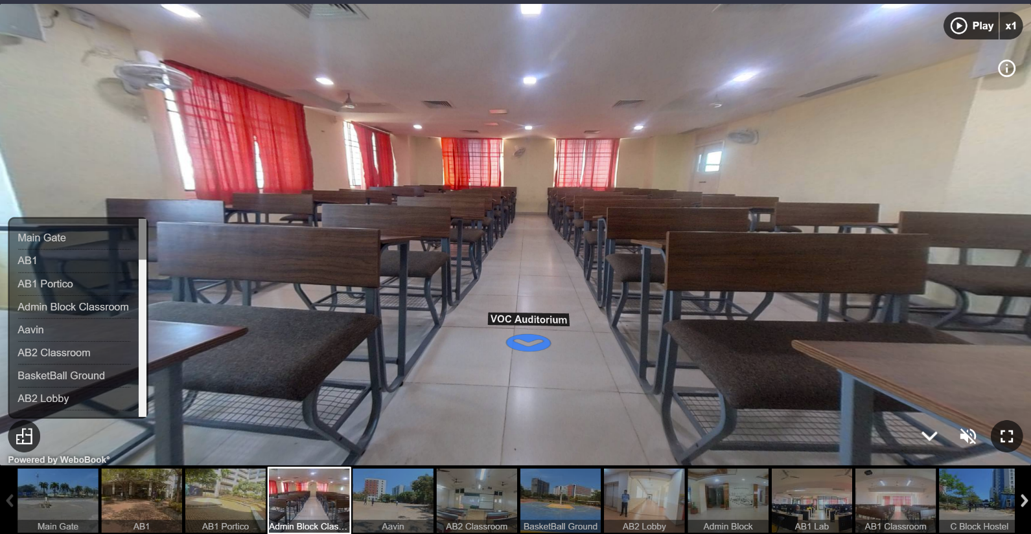

Fig.6.Admin Block Class Room-VIT CHENNAI

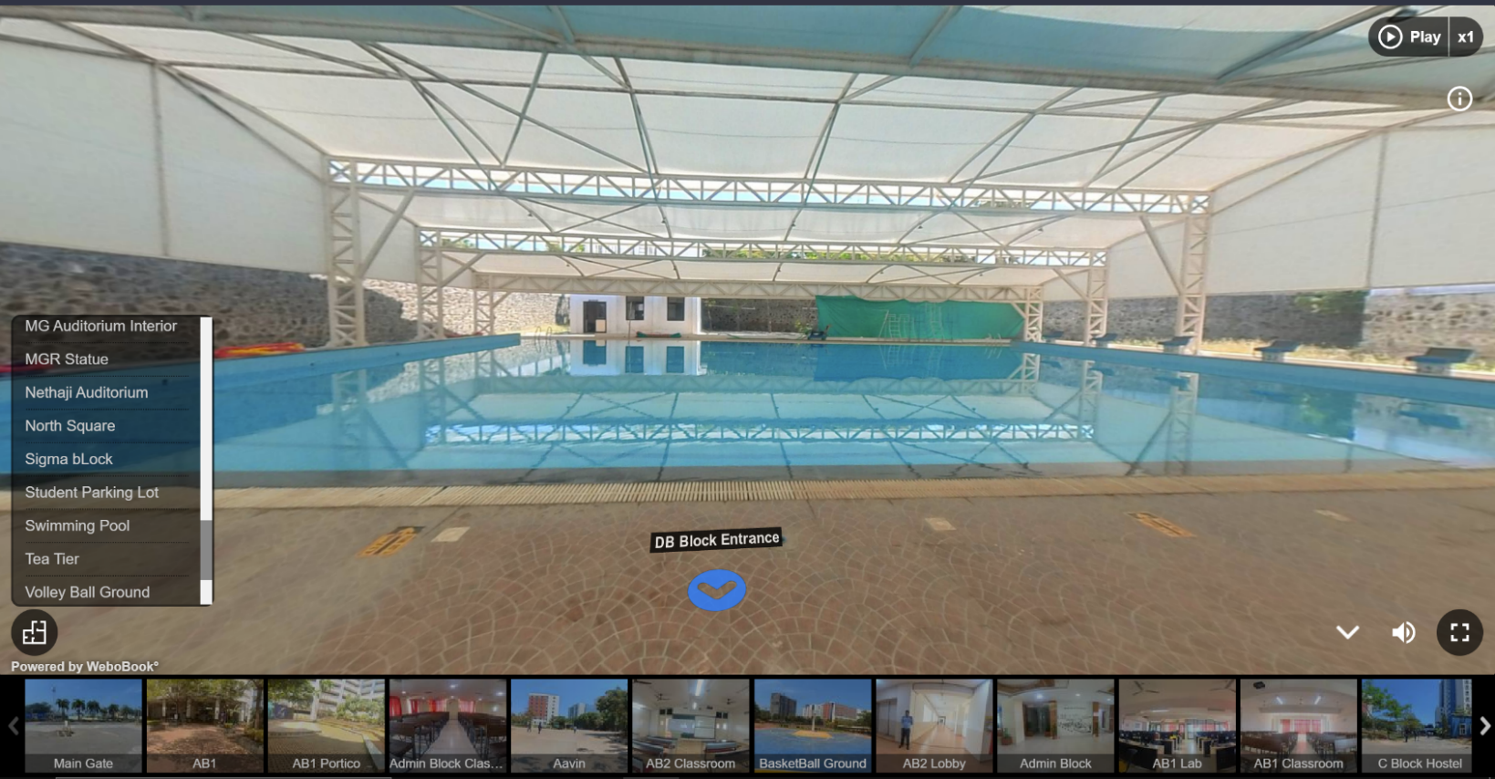

Fig.7. Swimming Pool-VIT CHENNAI

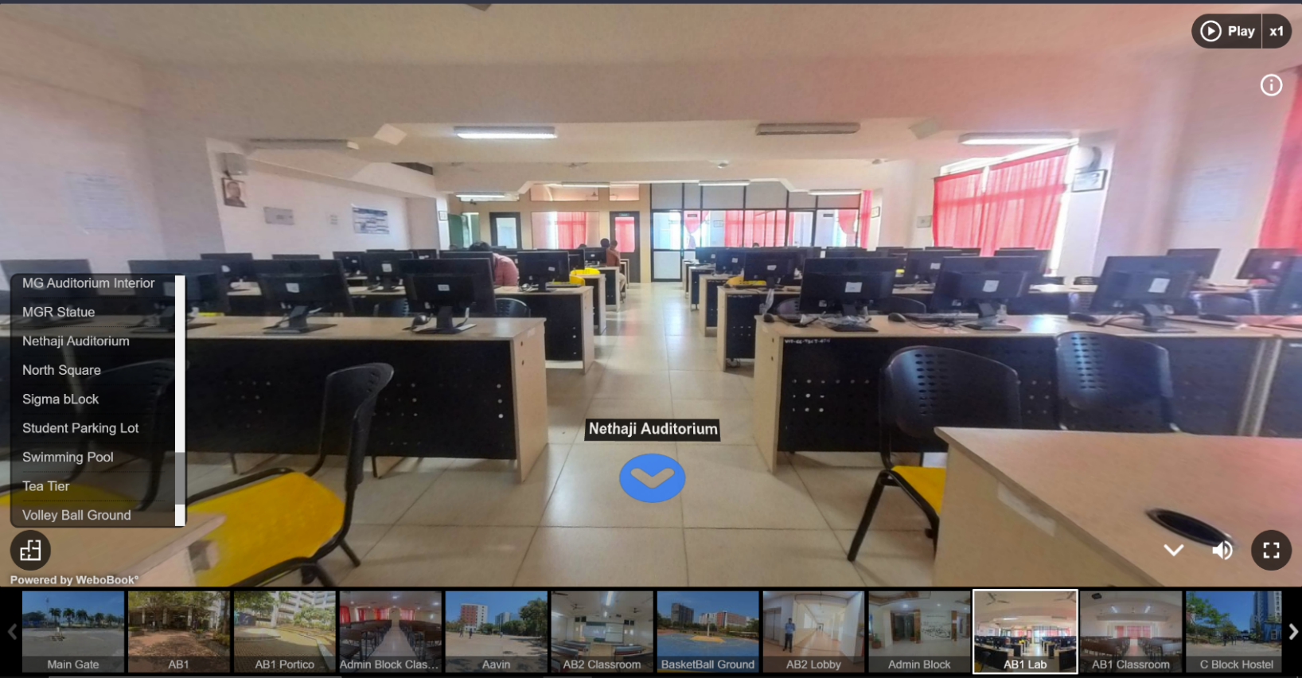

Fig.8. Academic Block-I Lab-VIT CHENNAI

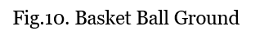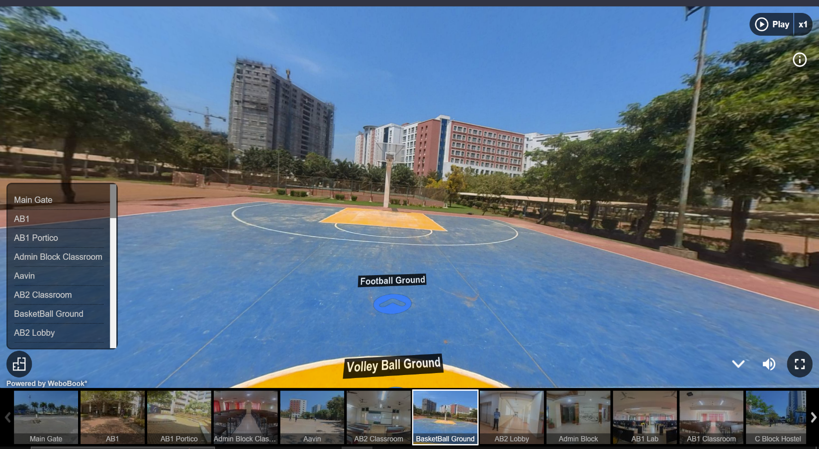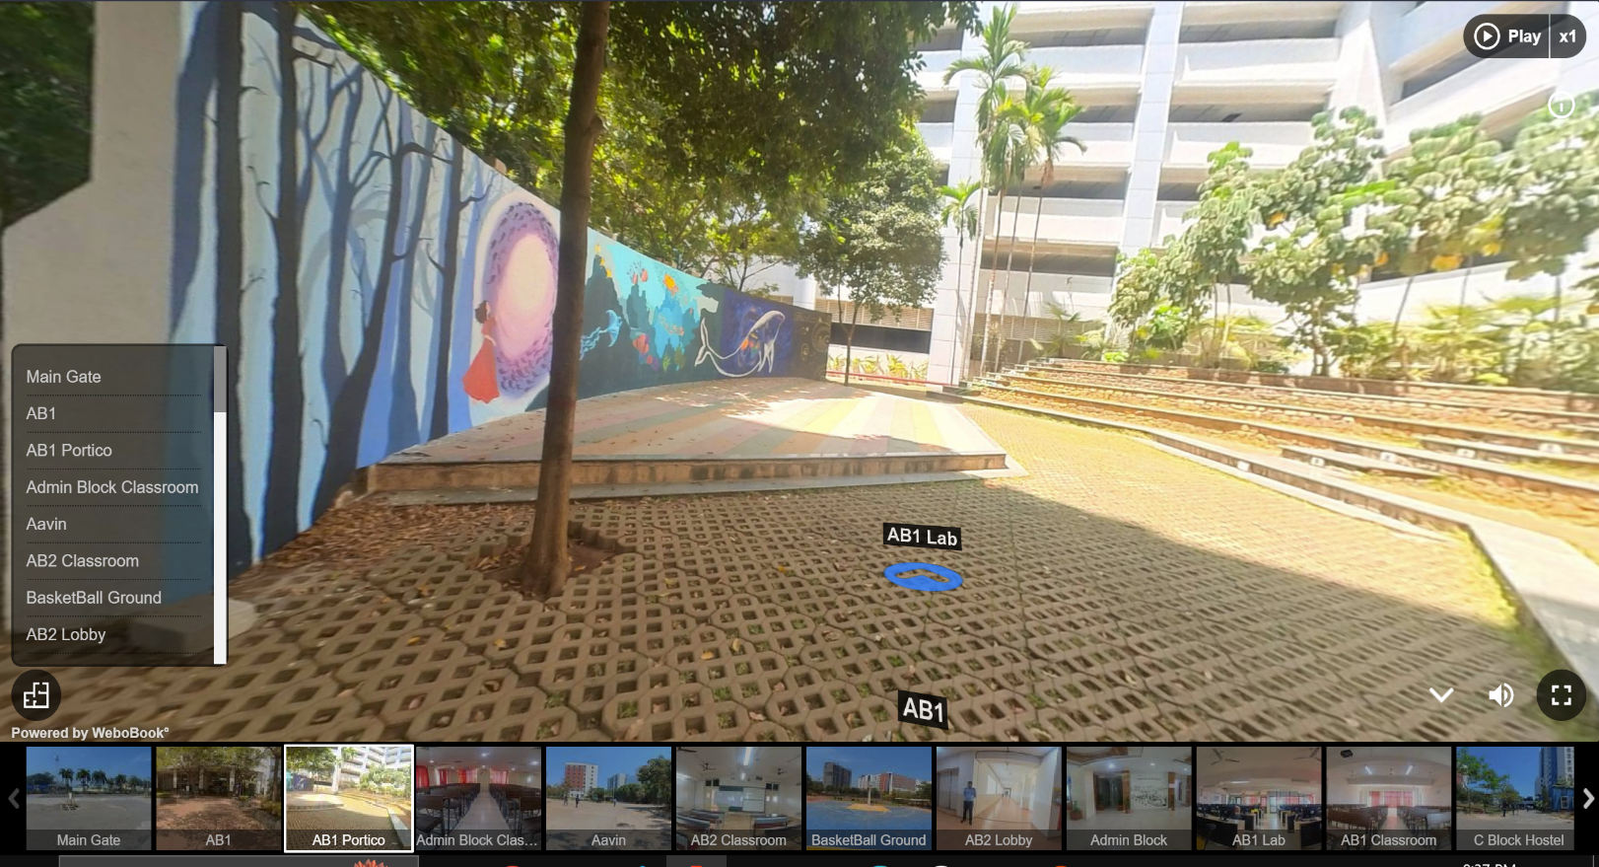 Fig.9. Academic Block-I Amphitheatre

Fig.11. 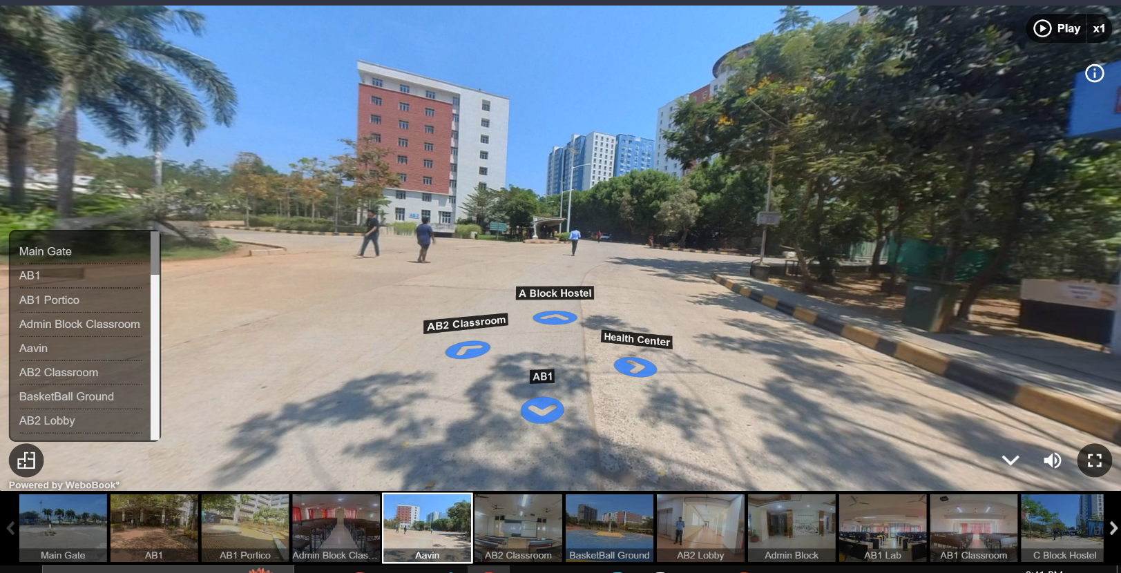Aavin Junction

**Chapter 7-Benefits**

The 360 virtual tour of VIT Chennai offers a unique and innovative way to showcase the campus to prospective students and other interested parties. The following points further elaborate on the benefits of this approach:

* Increased engagement: The 360 virtual tour provides a visually rich and interactive experience that can help to engage users in a more meaningful way than traditional marketing materials. Users can explore the campus at their own pace and choose their own path, which can help to create a more immersive and engaging experience. This can ultimately lead to a higher level of interest and excitement in the institution.
* Improved accessibility: The 360 virtual tour is designed to be accessible to all users, regardless of their physical location or abilities. This can help to reach a wider audience of prospective students who may not be able to visit the campus in person due to distance, time constraints, or other factors. This approach can also be particularly beneficial for international students who may not have the opportunity to visit the campus before enrolling.
* Cost-effectiveness: The 360 virtual tour is a cost-effective way to showcase the campus facilities and offerings to a wider audience. By providing a virtual tour, the institution can reach more prospective students without incurring the expenses associated with travel and other marketing efforts. This approach can also help to reduce the burden on admissions and marketing staff, who may not have to spend as much time and resources coordinating in-person visits.
* Personalization: The 360 virtual tour allows users to customize their experience by choosing their own path and exploring the areas of the campus that are most relevant to them. This can help to create a more personalized and engaging experience for users, which can ultimately lead to a higher level of interest and engagement in the institution.
* Real-time updates: The 360 virtual tour can be updated in real-time to reflect changes to the campus facilities and environment. This ensures that the tour provides an accurate and up-to-date representation of the institution, which can be important for prospective students who are considering attending. This approach can also help to maintain the interest and engagement of users who may revisit the tour multiple times before making a decision.
* Competitive advantage: By providing a 360 virtual tour, VIT Chennai can differentiate themselves from other educational institutions that may not offer a similar experience. This can help to attract more prospective students and increase enrollment in the institution. This approach can also help to position the institution as innovative and forward-thinking, which can be particularly appealing to students who are interested in cutting-edge technologies and approaches.

In summary, the 360 virtual tour of VIT Chennai offers a range of benefits that can help to increase engagement, accessibility, and cost-effectiveness while also providing a competitive advantage for the institution. By leveraging this approach, VIT Chennai can showcase their facilities and offerings in an engaging and personalized way, ultimately leading to increased interest and enrollment.

**Chapter 8: References**

1) T. Jung, M. C. t. Dieck, N. Moorhouse and D. t. Dieck, "Tourists' experience of Virtual Reality applications," 2017 IEEE International Conference on Consumer Electronics (ICCE), Las Vegas, NV, USA, 2017, pp. 208-210, doi: 10.1109/ICCE.2017.7889287.

2) T. Widiyaningtyas, D. D. Prasetya and A. P. Wibawa, "Web-based Campus Virtual Tour Application using ORB Image Stitching," 2018 5th International Conference on Electrical Engineering, Computer Science and Informatics (EECSI), Malang, Indonesia, 2018, pp. 46-49, doi: 10.1109/EECSI.2018.8752709.

3) R. K. Moloo, S. Pudaruth, M. Ramodhin and R. B. Rozbully, "A 3D Virtual Tour of the University of Mauritius using WebGL," 2016 International Conference on Electrical, Electronics, and Optimization Techniques (ICEEOT), Chennai, India, 2016, pp. 2891-2894, doi: 10.1109/ICEEOT.2016.7755226.

4) Huang, Yu-Chih, et al. “Exploring user acceptance of 3D virtual worlds in

travel and tourism marketing.” Tourism Management 36 (2013): 490-501.

5) <https://hmct.dypvp.edu.in/Documents/research-papers-publication/Resarch-publications/41.pdf>

6)<https://tigerprints.clemson.edu/cgi/viewcontent.cgi?article=1775&context=all_dissertations>

7) <https://www.insta360.com/support/supportcourse?post_id=20561>

8)<https://webobook.com/about>

9) <https://www.insta360.com/product/insta360-oner_twin-edition>

10)[https://www.youtube.com/watch?nsta360 One RS and One R Beginners Guide](https://www.youtube.com/watch?v=yrHcprg8HPE&ab_channel=360Vroomers)